

**LAKSHMI NARAIN COLLEGE OF TECHNOLOGY,**

**BHOPAL**

**PROJECT SYNOPSIS**

OF MINOR PROJECT

**ON**

**BANKING SYSTEM**

**BACHELOR OF TECHNOLOGY**

COMPUTER SCIENCE AND ENGINEERING

**SUBMITTED BY**

AADARSH TUSHAR

ARSHIKA SINGH

SEPTEMBER 2022

PROJECT MEMBERS DETAILS

Name of student - Aadarsh Tushar

University Roll No. - 0103CS201001

Class Roll No. - 01

Branch - CSE

Batch - 2020 – 24

Proposed Topic - Banking System

Name of student - Arshika Singh

University Roll No. - 0103CS201041

Class Roll No. - 40

Branch - CSE

Batch - 2020 – 24

Proposed Topic - Banking System

**Table of Contents**

|  |  |
| --- | --- |
| **CONTENT** | **PAGE NO** |
| **Introduction** | **3** |
| Rationale | **4** |
| **Objective** | **4** |
| **Feasibility Study** | **5** |
| **Methodology** | **6** |
| **Hardware requirements** | **7** |
| **Software requirements** | **7** |
| **Conclusion** | **8** |

1. **INTRODUCTION**

The “Online Place Booking System” has been developed to override the problems prevailing in the market areas of a city. This software is supported to eliminate and in some cases reduce the hardships faced by this existing system. Moreover this system is designed for the particular need of the company to carry out operations in a smooth and effective manner.

The application has removed third person between vendors and municipal corporation or any private organisation. It also provides error message while entering invalid data. No formal knowledge is needed for the user to use this system because application contains a simple and smooth UI/UX. Our application is providing “AI Chat Bot” which accepts the queries of the user and responds accordingly. Thus by this all it proves it is user-friendly.

E-booking of market place as described above, can lead to error free, secure, reliable and fast management system.

As we see that there is no proper management in the market place to set the stalls of the vendors, for ex- who will set their stalls where and when . This creates confusion among the vendors. The proposed system removes this confusion among the vendors. As there are multiple slots for the particular area in the application. So the vendor can see whether a particular slot is booked or not and also the vendor can choose a particular slot of his/her choice by using the application. There is a payment option for booking the slots, by paying the particular amount of money, slot is booked by the vendor.

This is designed to assist in strategic planning, and will help to ensure that the municipal corporation or any private organisation is equipped with the right level of information and details for your future goals. Also, for those busy executive who are always busy, our systems come with remote access features, which allow you to manage your workforce anytime, at all times. These systems will ultimately allow you to better manage resources.

1. **RATIONALE**

The purpose of “online Place Booking system” is to automate the existing manual system by the help of computerized equipment’s and full-fledged computer so that their valuable data/information can be stored for a longer period with easy accessing and manipulation of the same. The required software and hardware are easily available and easy to work with.

Online Place Booking system, as described above, can lead to error free, secure, reliable and fast management system. It can assist the user to concentrate on their other activities rather to concentrate on the record keeping of the booked slots/places . Thus it will help municipal corporation or any private organisation in better utilization of resources. The municipal corporation or any private organisation can maintain computerized records without redundant entries. There is also a review system for all the areas in a particular city, by using this feature the vendor can review the each area. And the Chat Bot facility is also provided, by using the Chat Bot section the vendor/user can also query about the areas/slots or other information.

1. **OBJECTIVE**

The aim is to automate its existing manual system by the help of computerized equipment’s and full-fledged computer software, fulfilling their requirements, so that their valuable data/information can be stored for a longer period with easy accessing and manipulation of the same. Basically the project describes how to manage for good performance and the data is not confusing to the vendors/users, whether a particular place is booked or not by anyone.

The main objective of the project on Online Place Booking system is to remove the involvement of third party for booking the places because in between the third party makes money for booking the places to the users. So this application removes the involvement of third party. It manages all the information about the booked slots/places . The project is total built at administrative end and thus only the administrator is guaranteed the access. The purpose of the project is to build an application program to reduce the manual work for managing the users or booked slots/places. It tracks all the details about the booked slots/places in a particular area.

1. **FEASIBILITY**

After doing the project “Online Place Booking System”, study and analysing all the existing or required functionalities of the system, the next task is to do the feasibility study for the project. All projects are feasible-given unlimited resources and infinite time .Feasibility study includes consideration of all the possible ways to provide a solution to the given problem. The proposed solution should satisfy all the user requirements regarding the online booking of slots/places and should be flexible enough so that future changes can be easily done based on the future upcoming requirements.

A. Economical Feasibility

This is a very important aspect to be considered while developing a project. We decided the technology based on minimum possible cost factor. All hardware and software cost has to be borne by the organization.

Overall we have estimated that the benefits the municipal corporation or any private organization is going to receive from the proposed system will surely overcome the initial costs and the later on running cost for system.

B. Technical Feasibility

This included the study of function, performance and constraints that may affect the ability to achieve an acceptable system. For this feasibility study, we studied complete functionality to be provided in the system, as described in the System Requirement Specification (SRS), and checked if everything was possible using different type of frontend and backend platforms.

C. Operational Feasibility

No doubt the proposed system is fully GUI based that is very user friendly and all inputs to be taken all self-explanatory even to a layman. Besides, a proper training has been conducted to let know the essence of the system to the users so that they feel comfortable with now system. As far our study is concerned the vendors are comfortable and happy as the system has cut down their loads of Booking the places Physically.

1. **METHODOLOGY**

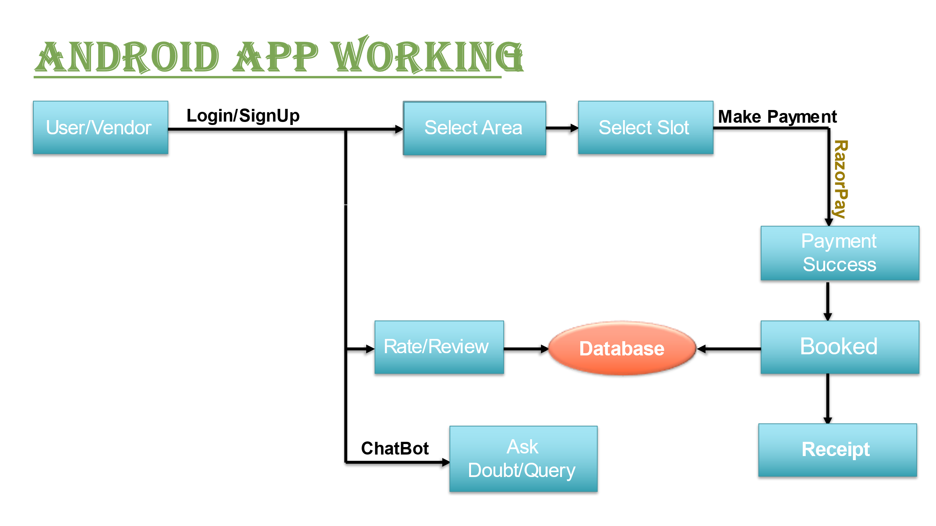

**6. SOFTWARE REQUIREMENTS**

**NAME OF COMPONENT SPECIFICATION**

Operating system - Windows XP, Windows 7/8/8.1/10

Language - Java, XML

Software - Android Studio

Database - MongoDB, Realm

Browser - Mozilla/Opera/Chrome

Web server software development kit -

**7.HARDWARE REQUIREMENTS**

**NAME OF COMPONENT SPECIFICATION**

Processor - Intel Core 13

RAM - 2GB

Hard Disk - 20GB

Monitor - 15 colour monitor

**8. CONCLUSION**

The aim of proposed system is to develop a system of improved facilities. The proposed system can overcome all the hardships faced by all the vendor and municipal corporation/any private organization. The system provides proper Management and reduces the manual work.

* User friendly UI and interactive.
* A chatbot for all queries.
* Record of every single rupee collected.
* Record of every vendor in a particular area.
* Notification on daily bookings
* Easy and multiple options for registration.
* Multiple options for payment.
* Rent collection through application.
* Increase in the number of upper middle class customer
* Greater efficiency.
* Minimum time required.
* **GGGGGGGGGGGGFFFaaaa**